

Graphic and functional
accessibility guidelines
Date | Version | Author | Statut / Comments
November 3, 2018 | 3.0 | Atalan | Minor content update.
August 10, 2020 | 4.0-v1 | Atalan | Major updates to ensure compliance with RGAA 4 and WCAG 2.1 (levels A and AA).
June 15, 2023 | 4.0-v2 | Atalan | Improved document accessibility.
August 22, 2023 | 4.1.2-v1 | Atalan | Minor content update: rephrasing a few sentences.
August 20, 2024 | 4.1.2-v2 | Atalan | Merging of sheet 7.4 (concerning the presence of subtitles) and 7.5 (concerning the readability of subtitles) into a single sheet 7.4.

Table of contents
Introduction 5
Context and objectives 5
Who should read this document, and how to use it? 5
Contact 6
License agreement 6
1. Navigation 7
1.1 Provide at least two of the following navigation methods: main menu, site map, and search engine 7
1.1.1 Site map examples 7
1.1.2 Search engine examples 8
1.2 Provide an accessibility statement 9
2. Colours 11
2.1 Make sure that there is sufficient contrast between the content and the background 11
2.1.1 Minimum contrast ratio 11
2.1.2 Colour Contrast Analyser 11
2.1.3 Alternative style guidelines 13
2.2 Make sure that there is sufficient contrast between informative and interactive graphic elements and the background 13
2.2.1 Minimum contrast ratio 14
2.2.2 Alternative style guidelines 15
2.3 Make sure that information is comprehensible even if the colours are absent 15
3. Links 18
3.1 Distinguish links from the surrounding text 18
4. Orientation and screen size 19
4.1 Do not restrict the ability to change the screen orientation 19
4.2 Design the interface in a responsive way 19
4.3 Do not remove features or content in the responsive views 20
5. Time management 23
5.1 Provide a way to control the session length 23
5.2 Provide a way to control automatic refreshes 23
6. Forms 25
6.1 Provide an explicit label for each form fields 25
6.2 Place each label next to the corresponding field 26
6.3 Provide an explicit button text for each button 27
6.4 Clearly indicate mandatory fields 28
6.5 Provide help for entering data 29
6.6 Provide explicit error messages and suggestions for correcting errors 30
7. Rich content and multimedia 32
7.1 Provide a heading or summary for all video and audio content 32
7.2 Provide a way of accessing the text transcript of all video and audio content 33
7.3 Provide a way of controlling the progress and the sound of all video and audio content 34
7.4 Provide a way of displaying the closed captions and make them readable 35
7.5 Provide a way of activating the audio description 37
7.6 Provide a method for controlling all animated content 37
7.7 Provide a way of accessing the detailed description of each rich content 39
8. Additional rules for compliance 41
Make one touch keyboard shortcuts deactivatable or reconfigurable 41
Make sure that the navigation is visually consistent 42
Provide an alternative to each CAPTCHA that is only a sound or only a visual test 42
Provide a way to control automatically triggered sounds 43
Use identical labels for form fields that have the same purpose 43
Complementary guidelines 45
Associate text with each ambiguous symbol 45
Do not justify the text 46
Group similar form fields together and give them a heading 47
Indicate the format and size of each document that can be downloaded 47
Indicate the language of each document available for download written in a foreign language 48
Keep accents on capital letters (for French, Spanish and any language containing accented characters) 49
Make the current position visually different in each navigation system 49
Plan sufficiently large and spaced hotspots 50
Provide a breadcrumb 51
Provide a confirmation message 51
Provide a heading for each data table 52
Provide an explicit link text for each link and each button 53
Provide a submit button at the end of each form 54
Provide a summary prior to final submission of multi step forms 56
Provide a way of returning to the previous steps on forms with multiple steps 56
Provide skip links 57

Introduction

Context and objectives
This documentation brings together all the accessibility specifications to consider during the graphic design and ergonomics stages of website or web application development (wireframes, prototypes, mock-ups, etc.) to ensure WCAG 2.1 compliance.
By taking these recommendations into account you can plan for the inclusion of a maximum number of accessibility criteria before the technical integration and development phases.
Several recommendations in this manual can also apply to the functional design of a website or web application (inclusion of a search engine, functionalities for a media player, etc.).
This manual is part of a set of four complementary manuals that can be downloaded from www.accede-web.com:
- Graphic and functional accessibility guidelines (this manual).
- HTML and CSS accessibility guidelines.
- Main rich interface components accessibility guidelines.
- Editors accessibility guidelines (template).

Who should read this document, and how to use it?
This document should be given to the stakeholders and/or service providers who create the functional specifications and graphic mock-ups. It should be used in addition to the project specifications, company graphic charter, and creative briefs. The recommendations may be supplemented with others, or left out, according to the circumstances—the project manager is often the most appropriate person for this task.
The recommendations should be taken into account during the graphic design phase, and for some of them, when creating storyboards and functional specifications.
Note
The online version of these guidelines comes with many examples, links to complementary resources, etc. This one is available at: https://www.accede-web.com/en/guidelines/graphic-functional/.

Contact
Please send any comments about this document to Atalan, the coordinator of the AcceDe Web project, at the following email address: accede@atalan.ca.
You can also find more information on the methodological guidelines of the AcceDe Web project at www.accede-web.com.

License agreement
This document is subject to the terms of the Creative Commons BY 3.0 license.
You are free to:
- copy, distribute and communicate the work to the public,
- change this work,
under the following conditions:
- Mention of the authorship if the document is modified:
  - You must include the Atalan and AcceDe Web logos and references, indicate that the document has been modified, and add a link to the original work at www.accede-web.com.
  - You must not in any circumstances cite the name of the original author in a way that suggests that he or she endorses you or supports your use of the work without its express agreement.
  - You must not in any circumstances cite the name of partner companies (Air Liquide, Atos, BNP Paribas, Capgemini, EDF, Generali, L’Oréal, SFR, SNCF, Société Générale, SPIE and Total), or the organizations which have supported this initiative (AbilityNet, Agence Entreprises & Handicap, AnySurfer, Association des Paralysés de France (APF), CIGREF, Design For All Foundation, ESSEC, Handirect, Hanploi, Sciences Po and Télécom ParisTech) without their express agreement.
The Atalan and AcceDe Web logos and trademarks are registered and are the exclusive property of Atalan. The logos and trademarks of partner companies are the exclusive property of Air Liquide, Atos, BNP Paribas, Capgemini, EDF, Generali, L’Oréal, SFR, SNCF, Société Générale, SPIE and Total.

Navigation

Provide at least two of the following navigation methods: main menu, site map, and search engine
At least two of the following three navigation methods must be available in the website:
- A main menu.
- A site map that shows the structure of the website, and at least allows the user to access all sections and functions of the website.
- A comprehensive search engine that provides a search on all the content (texts, documents, videos, etc.).
These items must be available in the same place on each page throughout the website.
Note
You can, of course, choose to have all three navigation methods in the same website.

Site map examples
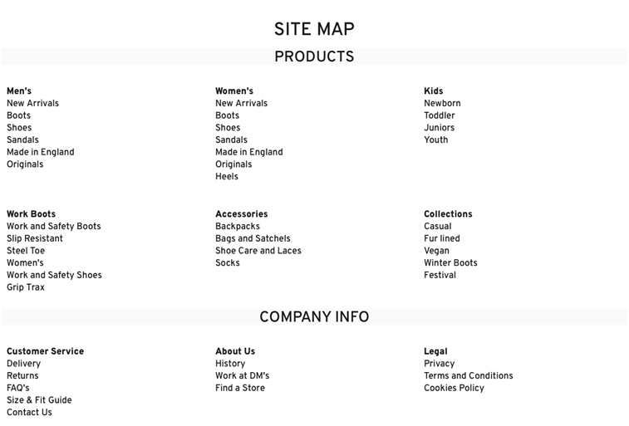
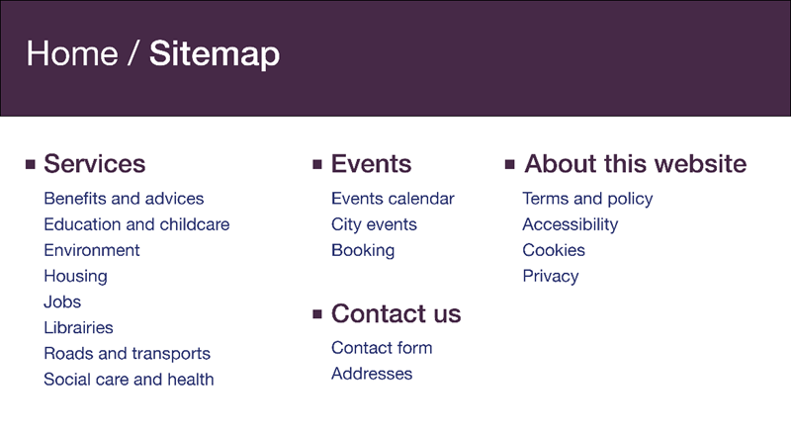
Examples of site maps.
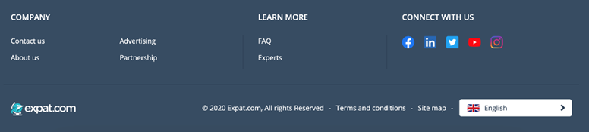
Example of a link to the site map at the bottom of the page.

Search engine examples
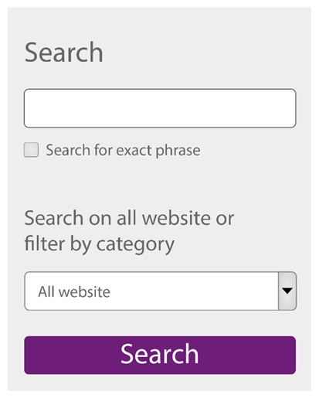
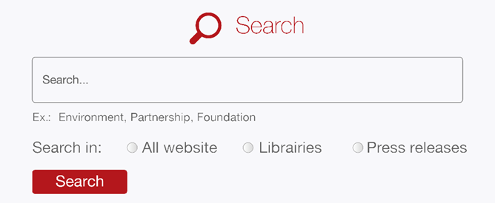
If necessary, it is possible to provide filters on the search engine
so that the results are more accurate.
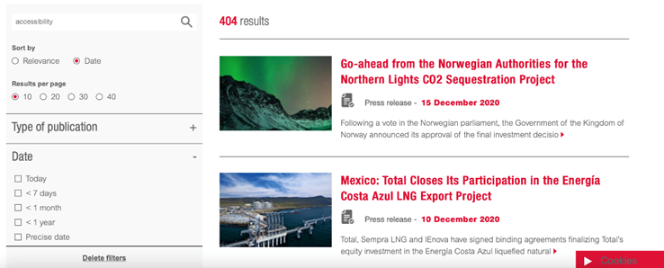
Screenshot of a search results page filtered by date.
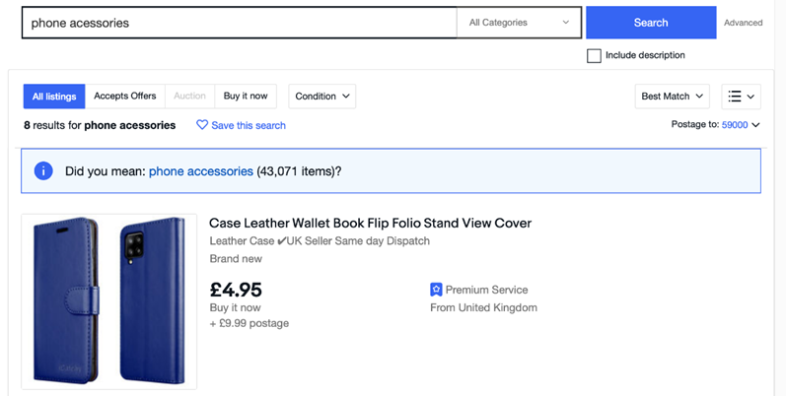
The presence of correction suggestions is a good accessibility practice.

Provide an accessibility statement
In the case of a website required to comply with the RGAA (Référentiel Général d’Amélioration de l’Accessibilité), an accessibility statement must be provided.
Warning
The information that must be included in this declaration can be consulted directly on the site of the RGAA – “Déclaration d’accessibilité” section.
An accessibility statement example is available on the same website.
Note
This accessibility statement and its link may for example be entitled "Accessibility", "Accessibility Statement" or "Accessibility Policy".
It must be available in the same place on each page throughout the website.

Colours

Make sure that there is sufficient contrast between the content and the background
The contrast between the text and the background must be sufficient.
This applies to all texts ("pure", embedded in images, animations, etc.).

Minimum contrast ratio
The minimum contrast ratio to reach depends on the size and weight of the texts.

Normal text
- The colour of a non-bold text with a font size lower than 18pt or 24px must have at least a contrast ratio of 4.5 with the background colour.
- The colour of a bold text with a font size lower than 14pt or 18.5px must have at least a contrast ratio of 4.5 with the background colour.

Big text
- The colour of a non-bold text with a font size higher or equal to 18pt or 24px must have at least a contrast ratio of 3 with the background colour.
- The colour of a bold text with a font higher or equal to 14pt or 18.5px must have at least a contrast ratio of 3 ratio with the background colour.
Note
The kind of font used has no impact on the contrast ratios to be reached.

Colour Contrast Analyser
To test the contrast you could use, for example, the Colour Contrast Analyser tool for Windows and Mac OS that you can download for free.
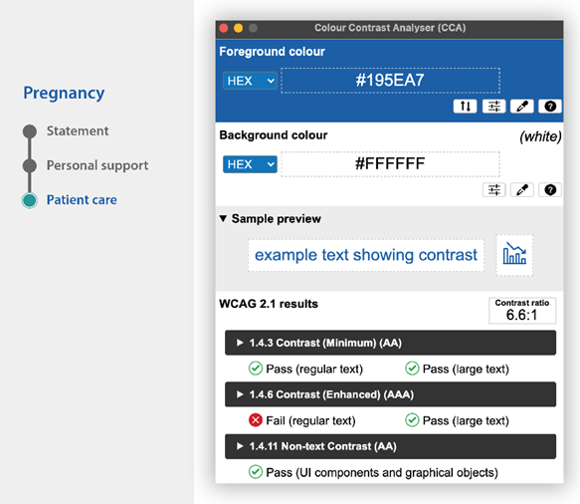
According to this tool, blue text on a gray background has a sufficient contrast ratio.
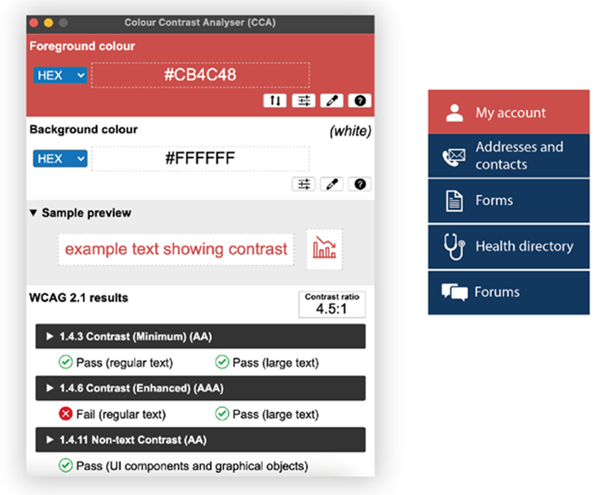
According to this tool again, the menu entry "My Account" in white
on a light red background has a sufficient contrast ratio.
Warning
Be careful when using gradients, transparency and background images.
Tips
- The Chart contrast analysis grid allows you to automatically calculate the contrasts of several colours.
- The Contrast Finder tool can be used to find sufficiently contrasted colour combinations.

Alternative style guidelines
If it is not practical to optimize the contrast, then you can create alternative style guidelines that offer sufficient contrast.
Alternative style guidelines do not necessarily push the contrast to the limits (for example, black on white, or white on black), but provide rules so that the association of colours is optimized satisfactorily.
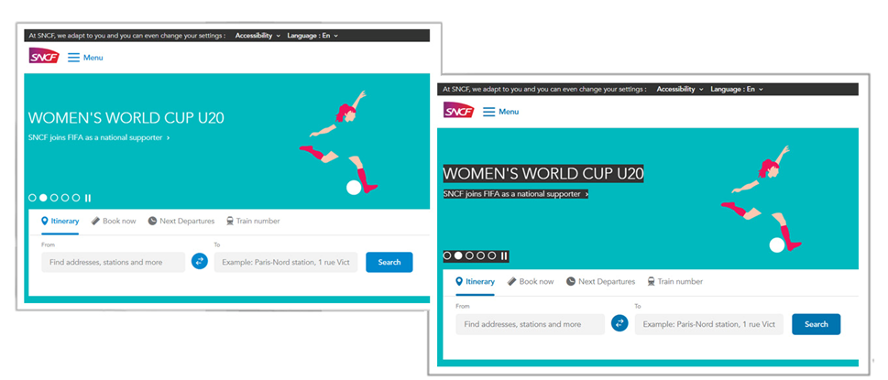
In this example, alternative style guidelines that are sufficiently contrasted
(on the right capture) can be activated from the button “Accessibility”
which opens a menu containing some accessibility parameters.

Make sure that there is sufficient contrast between informative and interactive graphic elements and the background
The contrast between informative and interactive graphic elements and the background must be sufficient.
It includes, in particular:
- Informative pictograms.
- Interactive pictograms alone, without label.
- Form fields.
- Tabs.

Minimum contrast ratio
The minimum contrast ratio to reach between the informative/interactive graphic elements and the background colour is of 3.
Note
To test the contrast ratio, use, for example, the Colour Contrast Analyser tool.

Examples of interactive pictograms with sufficient contrast.
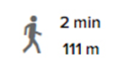
Example of an informative pictogram with sufficient contrast.
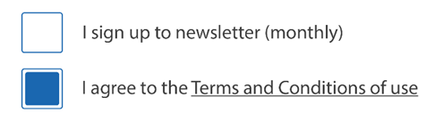
Examples of sufficiently contrasted checkboxes.
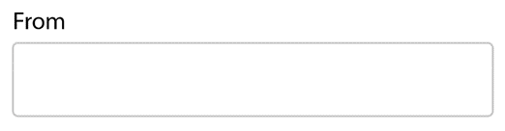
Example of a text field with insufficient contrast.
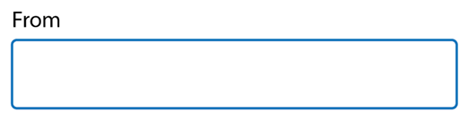
Example of a text field with sufficient contrast.

Alternative style guidelines
If it is not practical to optimize the contrast, then a sufficiently contrasted alternative style guidelines must be provided.

Make sure that information is comprehensible even if the colours are absent
Information must not be conveyed solely by colour.
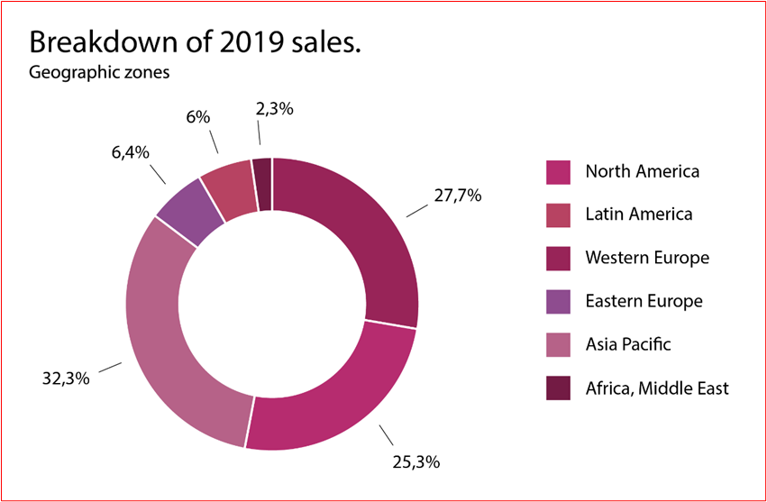

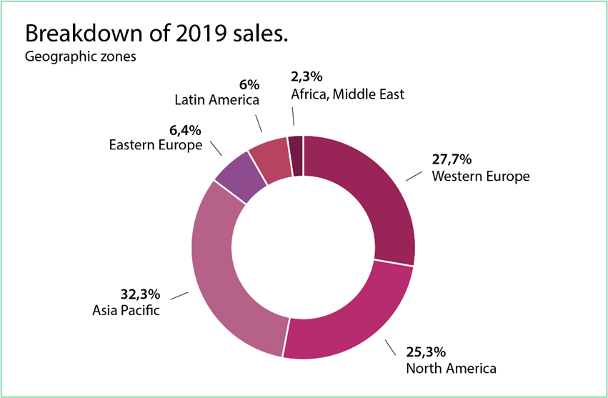
In the first example, the information in the pie chart can only be understood by associating each segment with a colour; the second version is comprehensible
even if the colours are absent.
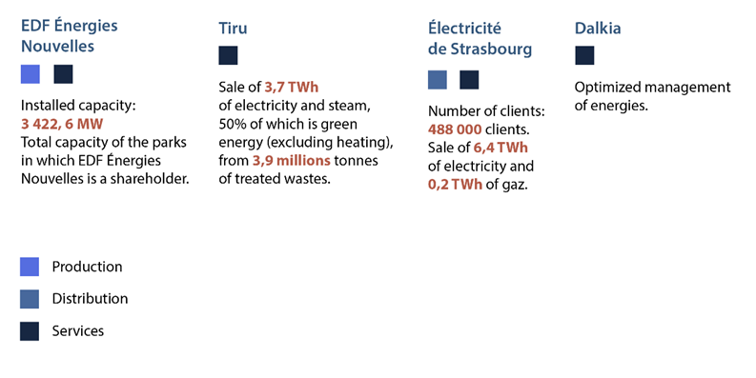
In this first example, squares of different colours are used for the legend. information is conveyed only by this means.
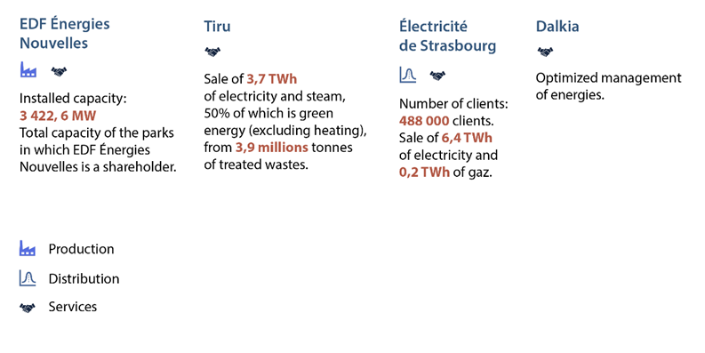
While in this version, the color squares have been replaced by pictograms. This makes the information understandable even in the absence of colors.
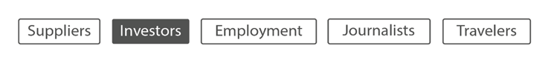
In this first example of a navigation menu, information regarding the current position (“Investors”) is only conveyed by a change in the background color.
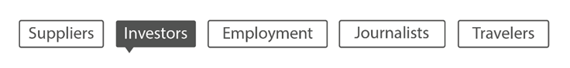
While in this version, the addition of a downward pointing arrow makes the information understandable even in the absence of colors.

In this first example of a carousel navigation system, the information regarding the current position is conveyed only by the color change.

While in this version, the shrinking of the current position makes it possible to make the information understandable even in the absence of colors.

Links

Distinguish links from the surrounding text
When links are included in content, they must be distinguished from the text surrounding them:
- Ideally, by not relying solely on color (by underlining them, for example).
- Otherwise, by applying the following rules:
  - Ensure that the contrast ratio between the color of the links and the color of the surrounding text is at least of 3.
  - Provide the appearance of links on hovering and keyboard focus by not relying on a color change (underlining, bold text, etc.).
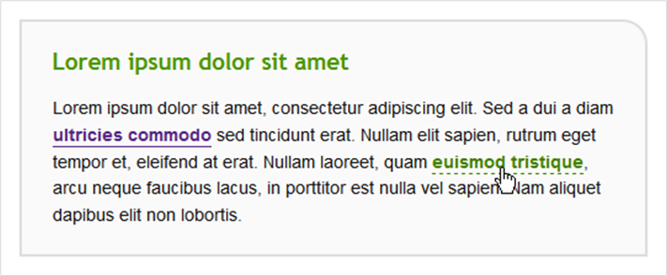
Example of a visual differentiation via underlining
between a link and its surrounding text.
Note
This rule does not apply to links included in link groups (menu items, for example), because their function is obvious.
Warning
You are strongly advised not to apply underlining to other elements than links.

Orientation and screen size

Do not restrict the ability to change the screen orientation
All content and features must remain available and usable regardless of screen orientation (portrait or landscape).
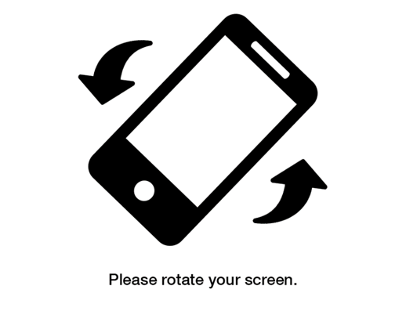
This example does not comply because access to the page is blocked by a message “Please rotate your screen” which forces the person to change
her screen orientation to keep browsing.

Design the interface in a responsive way
All content and features must remain available on a screen that is 320px wide or wider, without any horizontal scroll bars.
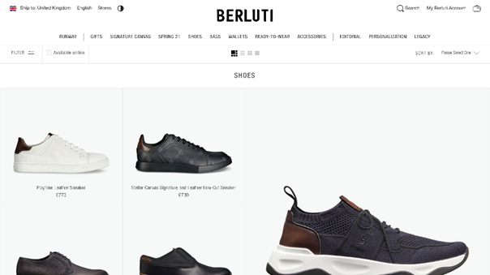
Illustration of a desktop view.
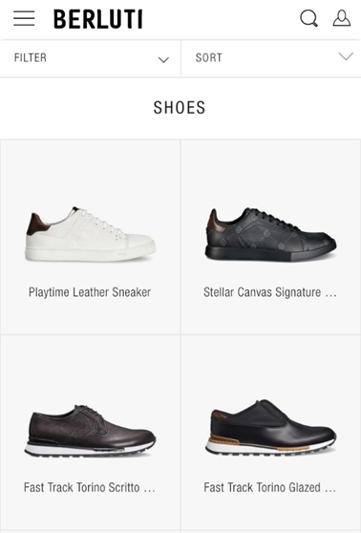
Illustration of the same view on mobile.

Do not remove features or content in the responsive views
Ensure that all content and features are available regardless of the screen size.
In particular, do not remove features (menus, filtering systems, interactive maps, etc.) and/or content (data tables, videos, etc.) from the responsive views.
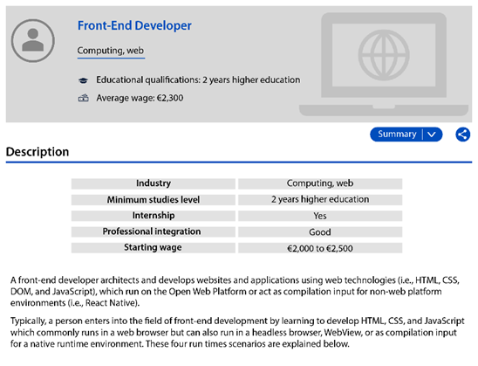
In the desktop version of this page, an abstract, a share button,
and a summary table are available.
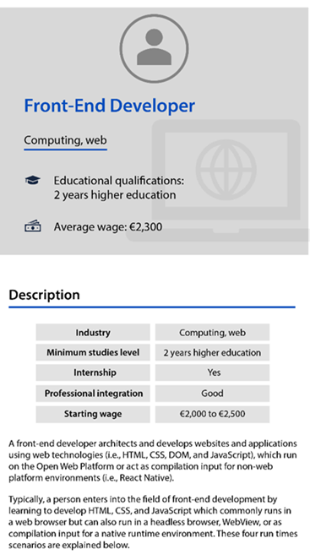

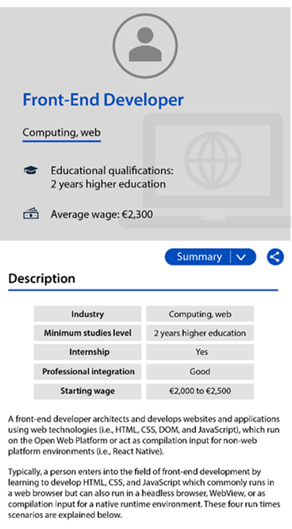
The summary button and sharing functionality must therefore also
be available in the mobile version.
Note
Content and features can disappear from one version to another if a means of accessing them remains available on the page.
For example, a search field displayed in the banner on the desktop version of the website can be removed from the banner in the mobile version if a link to the search engine is provided as a replacement.

Time management

Provide a way to control the session length
When a session is active (online purchases, bank data consultation, administrative procedures, etc.), a means of removing the session time limit must be provided.
Note
If it is not possible to completely remove the session time limit (for security reasons, for instance), then a way to extend it must be provided.
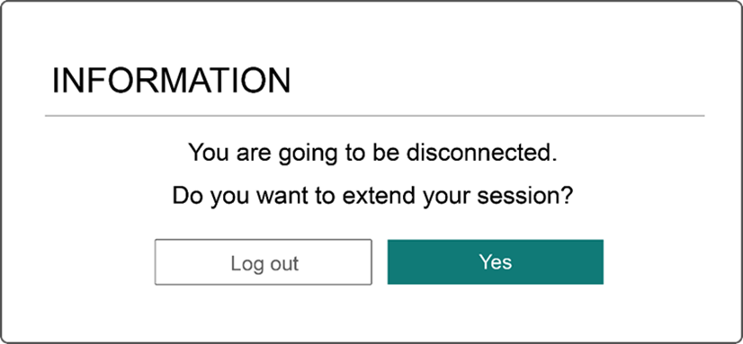
Before the end of the validity of the current session, this website offers a functionality which allows to extend its duration.

Provide a way to control automatic refreshes
When all or part of the page reloads automatically (news feed, stock price, roadmap, etc.), a way to disable and re-enable automatic refreshes must be provided.
Note
If it is not possible to completely disable automatic refreshes, then a way of spacing them out in time must be provided.
Tip
If the website offers many automatic refreshes, a good practice is to provide a centralized system for disabling and re-enabling all refreshes.
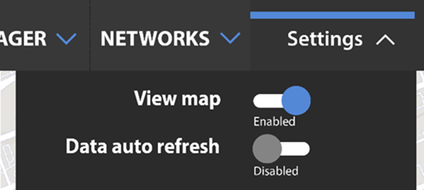
This website provides a "Data auto refresh" feature that allows to enable or disable automatic refreshes.

Forms

Provide an explicit label for each form fields
An explicit label must be provided for each form field.
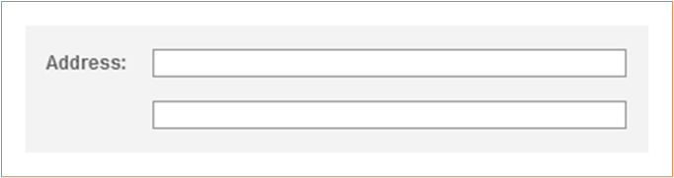
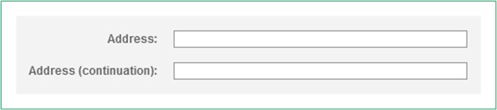
In this example, a label has been added to the field for the second line of the address.
Note
If it is not practical to add a label for each field (lack of space in the mock-up, for example), there are other solutions that can be used later in the development phase.
Nevertheless, this is a compromise solution that is less effective than directly optimizing the form field label.
In this example of search field, a "Search" button compensates
for the absence of an explicit label.
Warning
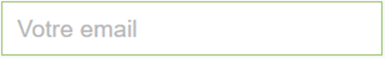
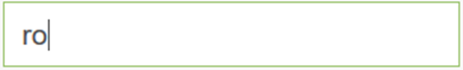
Placeholders must not be used as labels since they disappear when the field is filled.

Place each label next to the corresponding field
Each label must be placed close to the field to which it is attached:
- Either immediately above the field.
- Or immediately:
  - To the right of the field for radio buttons and checkboxes.
  - To the left of the field for all other field types.
There must only be a few pixels that separate a label from its corresponding field so that their association is visually obvious.
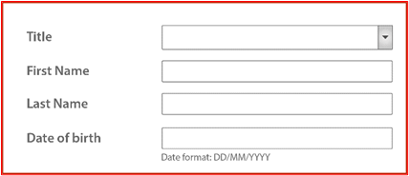
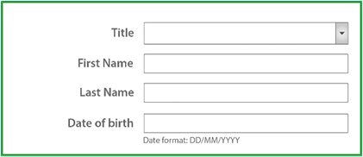
In this example, labels are right-aligned so that they are next
to the corresponding fields.
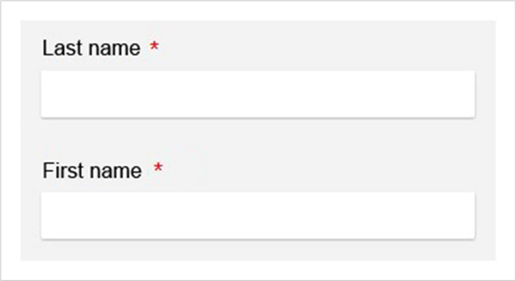
In this example, the headings are positioned immediately
above their respective form fields.
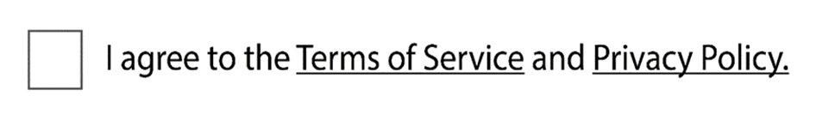
In this example, the checkbox is positioned immediately to the left of the label.

Provide an explicit button text for each button
An explicit button text must be provided for each button. The purpose of the button must be easily understood just by reading the button text, even if it is read out of context.
Button texts with the following text should therefore be avoided:
- "OK".
- "Validate".
- "Confirm".
- Etc.
They should be replaced by button texts such as:
- "Register".
- "Go to step 2".
- "Confirm payment".
- Etc.
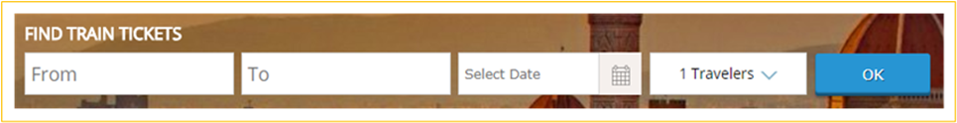

In this example, the “OK” button has been replaced by a “Find Tickets” button,
which is more precise.
Note
If it is not practical to add a button text for some buttons (lack of space in the mock-up, for example), there are other solutions that can be used later in the development phase.
Nevertheless, this is a compromise solution that is less effective than directly optimizing the button text.
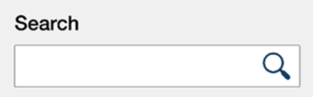
In this example, the image button represents a magnifying glass.
It will be made accessible during the technical phase

Clearly indicate mandatory fields
On each form, mandatory fields must be clearly indicated:
- A distinctive sign (“*” symbol, “mandatory” mention, etc.) must be provided in the label of each mandatory field.
- If a symbol is used to declare mandatory fields, a statement placed at the beginning of the form must indicate that the symbol stands for a mandatory field.
Note
If all the form fields are mandatory, then the statement “All fields are mandatory”, placed at the beginning of the form, may be sufficient.
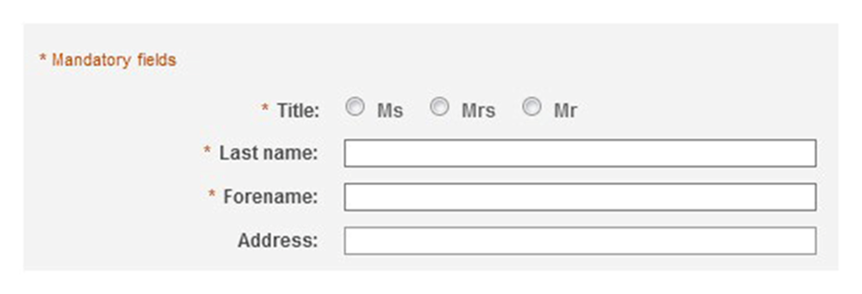
In this example, mandatory fields are indicated with an asterisk.

Provide help for entering data
Whenever the user is expected to enter values in a specific format in a form field, this must be indicated to the user.
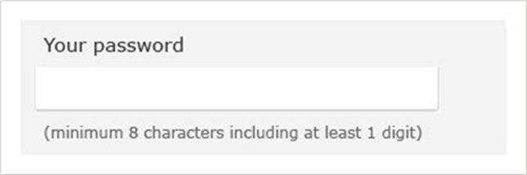
In this example, the password complexity requirements are specified close to the field.
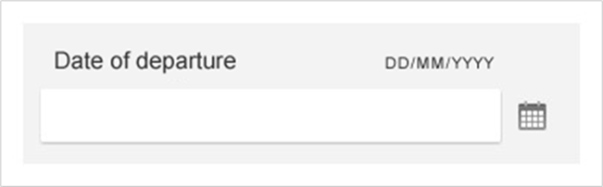
In this example, the format required for the date of departure
is specified close to the field.
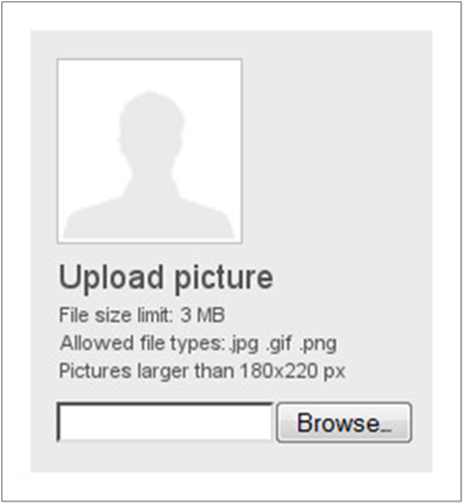
In this example, information concerning the format and size of the document
is provided before the document is sent.
Tip
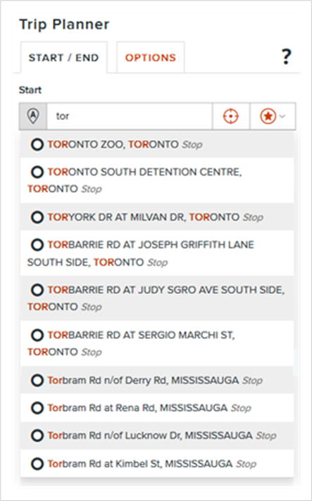
In addition to the mandatory helpers, a good practice is to provide autocompletion systems on the free entry fields (global search, route search, etc.).

Provide explicit error messages and suggestions for correcting errors
Whenever there is a possibility that a form returns errors, the following items must be provided:
- Explicit error messages.
- Suggestions for correcting errors.
Error messages must be explicit. That is to say, just by reading the error message:
- The field concerned must be identifiable.
- The cause of the error must be understandable.
- Suggestions must be provided when an error is due to an incorrect input format.
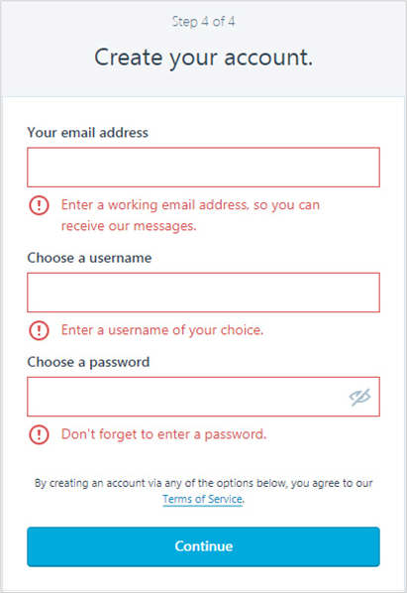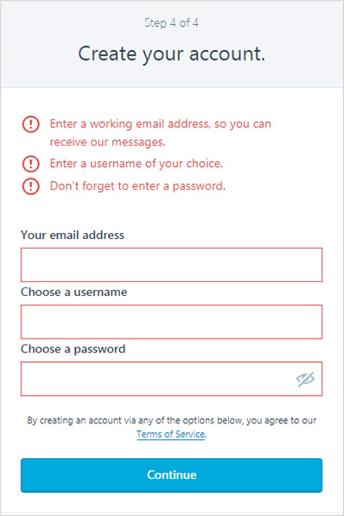
In the two examples above, the error messages are thorough
and are accompanied by suggestions for correcting the errors.
Warning
Error messages must not disappear automatically.
These messages must only disappear on a user action (closing button, display of a new page, new form submission, etc.).

Rich content and multimedia

Provide a heading or summary for all video and audio content
To highlight each video, a heading and/or summary must be provided.
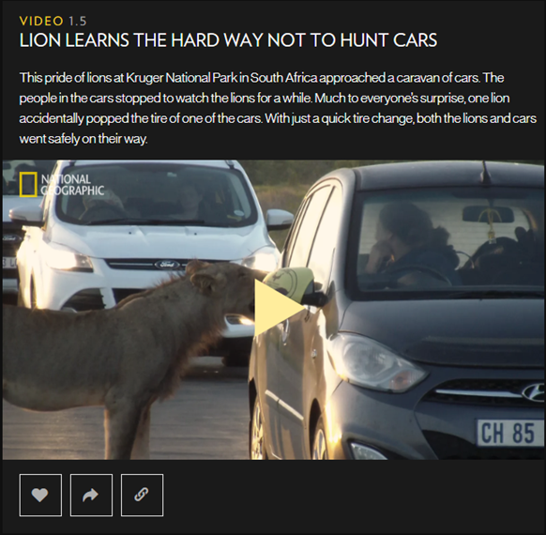
The video above is accompanied by a heading and a short presentation text.
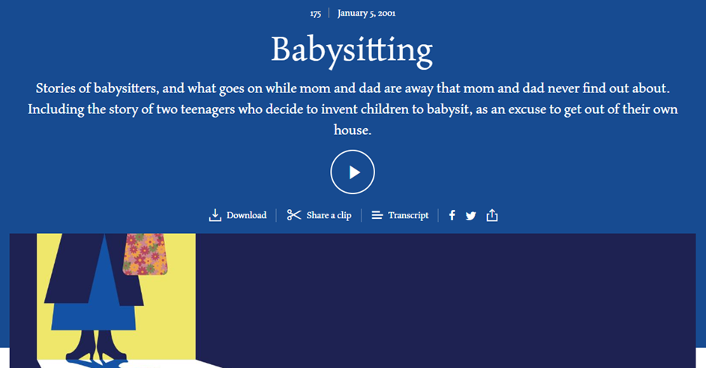
The audio content above is accompanied by a heading and a short presentation text.

Provide a way of accessing the text transcript of all video and audio content
The user must have a way of accessing the text transcript of all video and all audio content.
This text transcript must be available:
- Either directly on the same page near the video or the audio content.
- Or on another page, available from a link close to the video or the audio content.
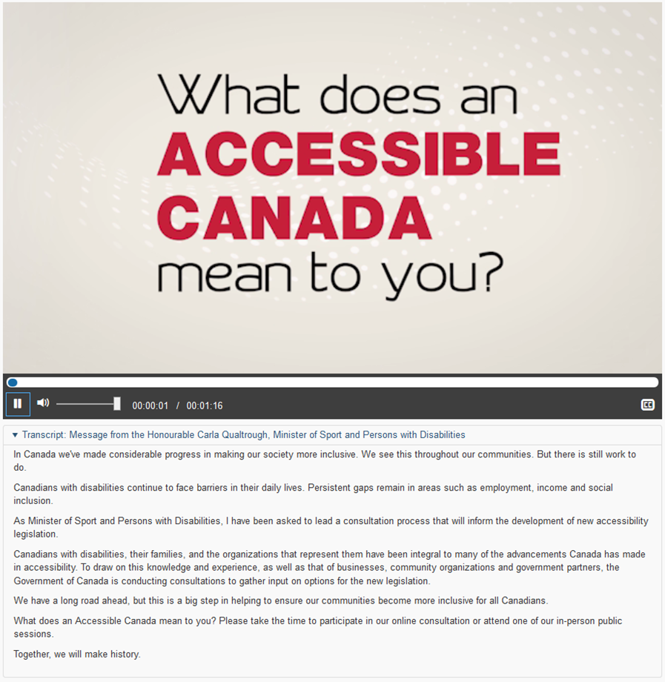
Example of a text transcript directly under the video.
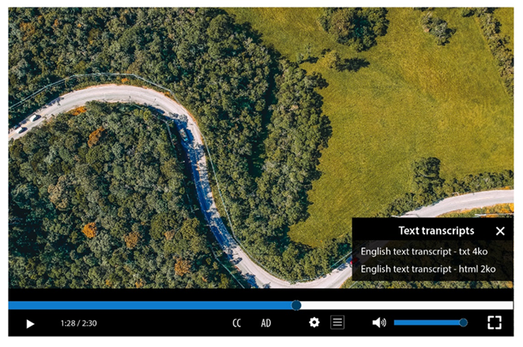
Example of links to download the text transcript of a video.
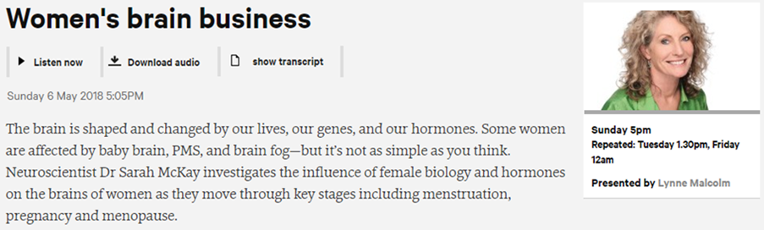
Example of a link to the text transcript of the audio content.

Provide a way of controlling the progress and the sound of all video and audio content
The following controls must be included with all video and audio content:
- Progress controls, play button and stop and/or pause button.
- Sound controls: mute/unmute sound button.
Tip
It is moreover interesting to provide for each video and audio content:
- A way to control its volume.
- Information about the current position and its total duration.
- Ways to control its progress (progress bar, fast-forward/rewind buttons, etc.).
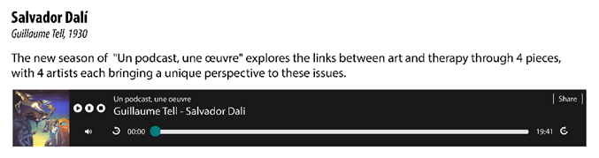
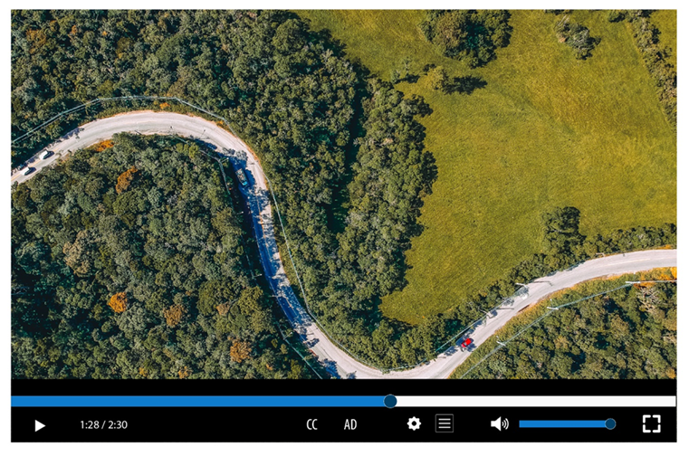
These examples of audio and video players are compliant because they offer the following buttons: play/pause, sound on/off and volume control.

Provide a way of displaying the closed captions and make them readable
You must provide a way of displaying and hiding the closed captions for each video.
Whenever closed captions are displayed, the contrast between the text and the video in the background must be sufficient.
Tip
To ensure that closed captions are readable whatever the situation, consider, for example, adding a black background behind white closed captions or a dark outline around light text.
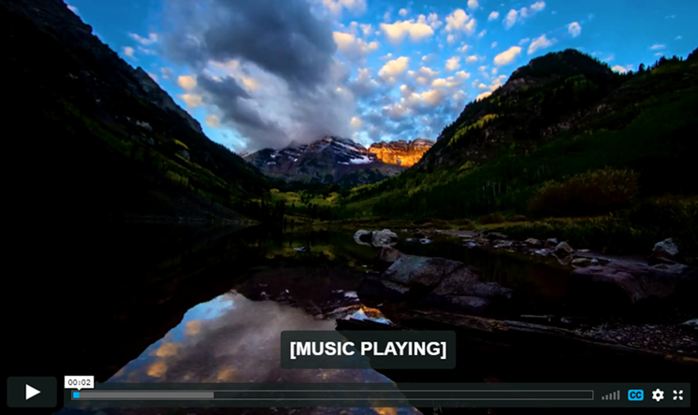
The “CC” button is used for activating the closed captions
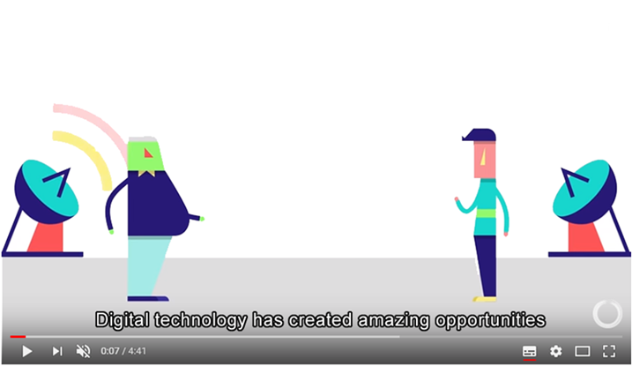
Closed captions with a white type and black outline, for example,
ensure that text is readable in all contexts.
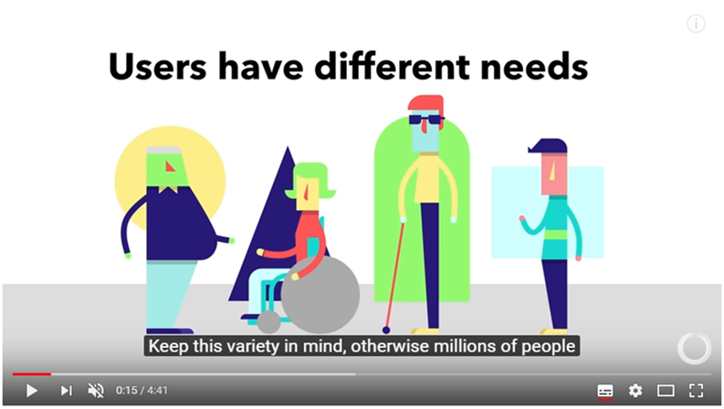
A background that is opaque or semi-transparent also ensures
that the text is easily read.

Provide a way of activating the audio description
A way of activating or deactivating the audio description must be provided with each video.
Note
The audio description uses a voice-over to provide the information that is conveyed by the image only. It is useful for all people who cannot see the video correctly (blind and visually impaired people).
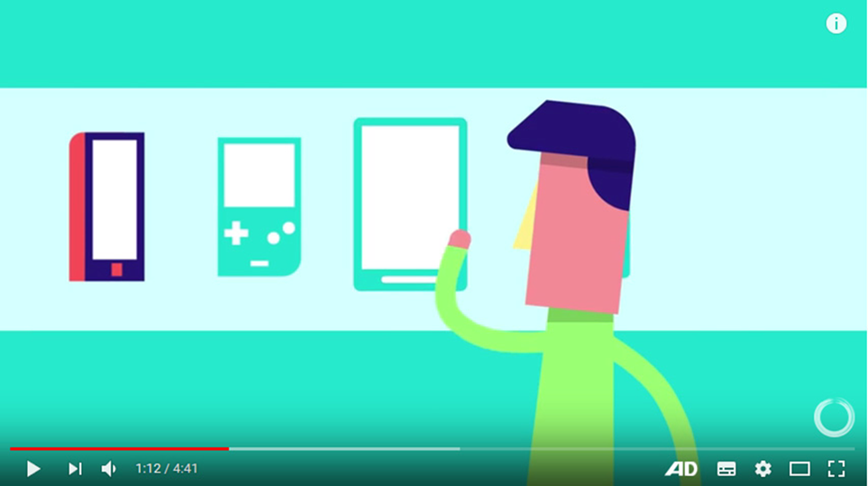
The "AD" button (for Audio Description) is used to activate the audio description.

Provide a method for controlling all animated content
A way to pause and restart animation must be provided for each animated content (scrolling, flashing, movement, etc.).
Note
You do not need to provide a progress bar or pause/play button for animations that last less than 5 seconds.
Tip
If the website offers a lot of moving content, a good accessibility practice is to provide a centralized system for deactivating and restarting all animations of the website at once.
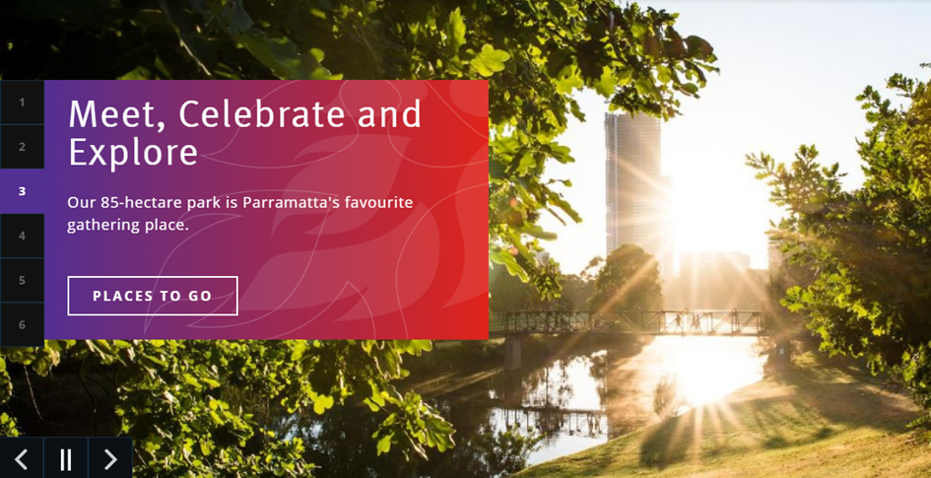
This animated carousel has a button for pausing the movement.
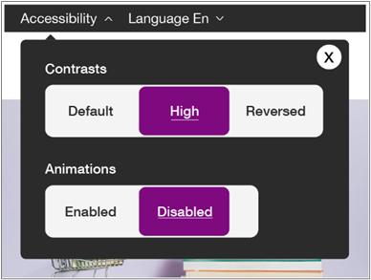
This feature allows you to enable or disable from a single place
all the animations of the site.

Provide a way of accessing the detailed description of each rich content
A way of accessing the detailed description must be provided for each rich content.
Note
A rich content is a content carrying so much information that it is necessary to provide in parallel a detailed description in text format.
Here are some examples of rich contents:
- An infography.
- A graph (diagram, curve, etc.).
- A geographical map.
This detailed description must be provided:
- Either directly on the same page near the rich content.
- Or on another page, available from a link near the rich content.
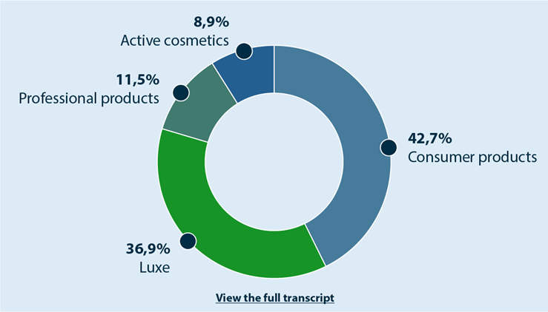
This infography carries complex information. A “View the full text transcript” button allows the display of a detailed description of this rich content.
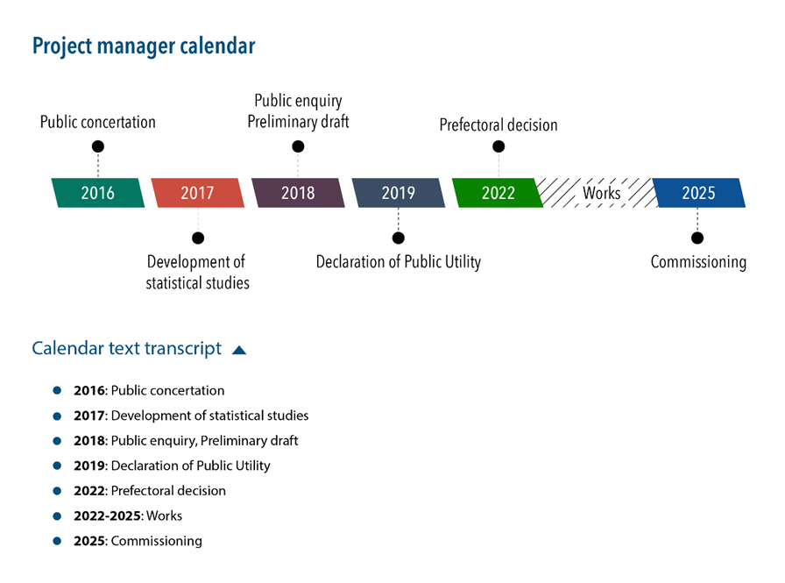
This calendar is an image carrying complex information. A "Calendar text transcript" button allows the display of a detailed description of this rich content.
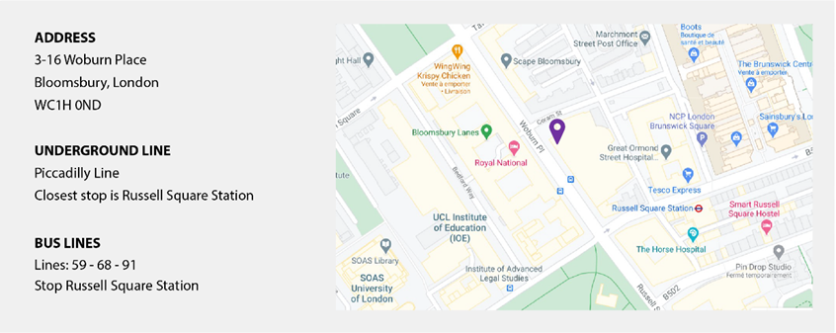
This map carries information and is accompanied by a text alternative indicating the address as well as the metro station and bus lines in the surroundings of the address.

Additional rules for compliance
Some criteria present in the accessibility standards have not been retained in the body of this notice because they are considered to be rarely applicable.
However, following these additional rules is necessary to ensure RGAA 4.1.2 and WCAG 2.1 compliance.
They are listed below:
- Limit the use of flash effects
- Do not provide information based on shape, size or position only
- Do not open a new window automatically
- Allow the control of redirections
- Provide an alternative for each functionality based on the movement of the device and/or the person
- Provide an alternative via a simple gesture for each complex gesture that serves as a feature control
- Provide a means to modify, delete or recover one’s own data of a legal or financial nature, or related to the passing of a test or examination
- Provide a summary for each complex data table
- Provide accessible office documents (PDF, DOC, etc.) or provide equivalent accessible alternative versions

Make one touch keyboard shortcuts deactivatable or reconfigurable
Keyboard shortcuts consisting of only one key must be :
- Deactivatable.
- And/or reconfigurable (to allow them to be replaced by multi-key combinations with Ctrl, Alt, etc.).
Note
This rule is not valid for keyboard shortcuts that are only functional when the focus is positioned on a specific element (for example, the down arrow key that opens a dropdown list when the focus is positioned on it).

Make sure that the navigation is visually consistent
Throughout the website, the appearance and position of items must be consistent (though not necessarily identical):
- Navigation menus.
- Search engine.
- And, generally, all the items that appear on every page (breadcrumb, site map link, etc.).
Note
The appearance of the home page may be different than the rest of the website.

Provide an alternative to each CAPTCHA that is only a sound or only a visual test
For each CAPTCHA (anti-spam system) that is only a sound or only a visual test, an alternative must be provided.
For example:
- A sound alternative.
- A text alternative in the form of a simple or mathematical question.
Note
For each CAPTCHA, it is highly recommended to provide a way to refresh its content because it happens very regularly that the CAPTCHA cannot be deciphered at the first reading.
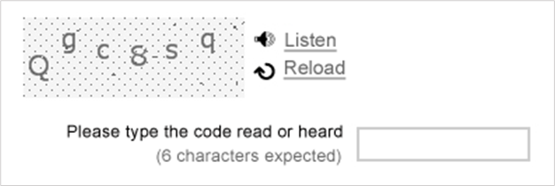
In this CAPTCHA, the link “Listen” provides the user with a sound version of the CAPTCHA.
Tip
Good practice is to provide, in addition to the reload solution, information on how to contact the website manager, if the CAPTCHA cannot be typed in (a link to the “Contact” page, a phone number, etc.).
Warning
CAPTCHAs are designed to block spambots that use more and more sophisticated techniques to circumvent them.
CAPTCHAs are therefore more and more complicated to decipher.
In addition, Google’s widely-used reCAPTCHA v2 captcha, which is presented as a checkbox followed by an image test, is not considered compliant, and its validation can be very difficult for keyboard and screen reader users. We therefore recommend the use of captchas that require no user action, such as the Friendly Captcha or the reCAPTCHA v3 of Google.

Provide a way to control automatically triggered sounds
A means of controlling automatically triggered sounds must be provided.
Note
The RGAA tolerates automatically triggered sounds if their duration does not exceed three seconds.

Use identical labels for form fields that have the same purpose
Whenever fields with the same function are provided several times on the website, their label must also be identical.
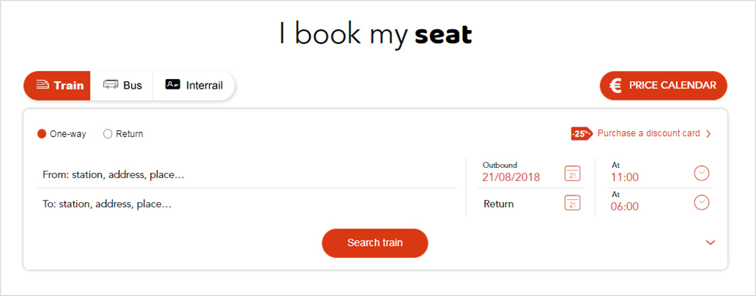
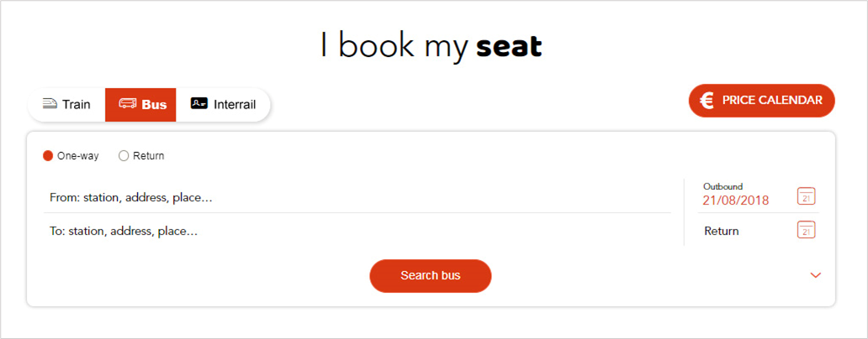
In this example, regardless of the tab (“Train”, “Bus” or “Interrail” tab), the labels “From” and “To” are identical. It would have been bad practice, for example, to put “To” on one tab and “Arriving in” on another.

Complementary guidelines
In addition to the mandatory rules detailed in the previous sections of this notice, taking into account the complementary guidelines listed below has a beneficial impact on people with disabilities.
Therefore, we strongly recommend that you apply them.
- Limit the length of a line to 80 characters
- Provide sign language interpretation for each audio content
- Allow a margin between paragraphs of at least 1.5 times the value of line spacing
- Allow a line spacing of at least 1.5 times the size of the text
- Provide a way to disable all the animations, including the transition effects.

Associate text with each ambiguous symbol
If symbols whose meaning is not obvious are used, they should:
- Be accompanied by a text that clarifies their meaning.
- Be located near the accompanying text.
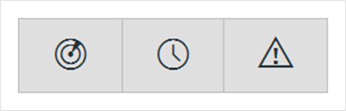
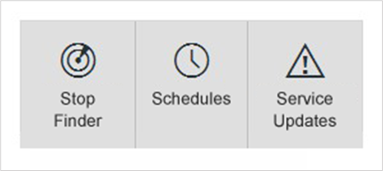
In this example, symbols that could be ambiguous
are combined with text that makes them more explicit.
Note
If it is not practical to associate a text with specific symbols whose meaning may not be clear (lack of space in the mock-up, for example), some solutions may be found later on in the development phase (by adding tooltips, for example).
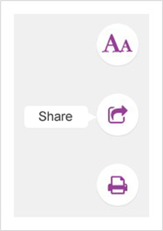
In this example, symbols that could be ambiguous
are combined with text displayed in tooltips.
Nevertheless, these are compromise solutions that are less effective than optimising the symbol directly with associated text.

Do not justify the text
Justification of the text can lead to reading difficulties.
It is therefore recommended not to justify the text by favouring a left-hand alignment instead.
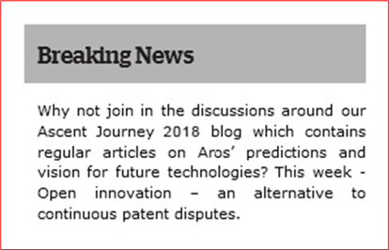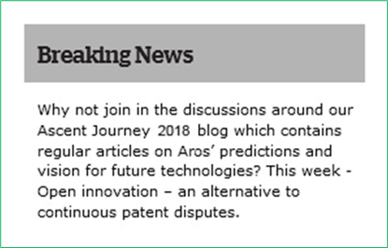
In this first example, the justified text leads to irregular and large gaps
between words, which may lead to difficulties in reading the text.

Group similar form fields together and give them a heading
Whenever fields of the same type are present in long forms, it is recommended to:
- Visually group them together.
- Introduce them with a clear and concise heading.
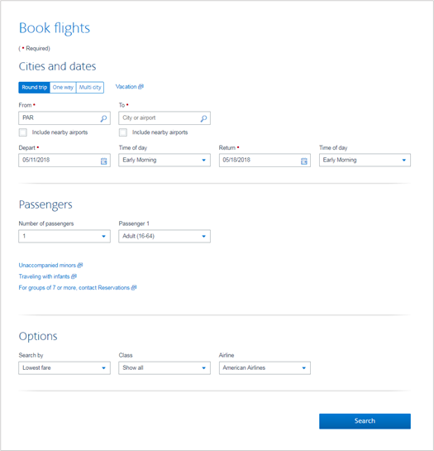
In this example, the fields are grouped by categories:
“Cities and dates”, “Passengers” and “Options”.

Indicate the format and size of each document that can be downloaded
For each link that points to a document that can be downloaded, the following information should be included in the link text:
- Title of the document.
- Format of the document.
- Size of the document.
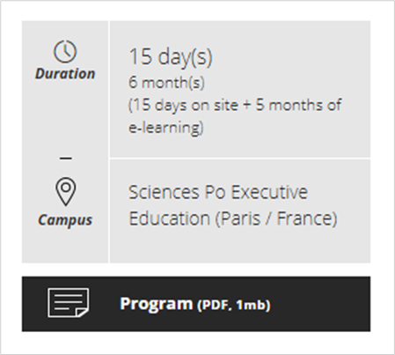
Example of indication of size and format of a PDF document.

Indicate the language of each document available for download written in a foreign language
Whenever a link points to a document available for download in a different language than the main language of the page, then the language of the document should be indicated in the link text.
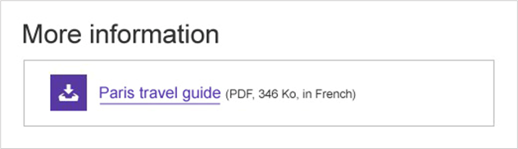
Example of an indication of the language of a PDF document.
Note
If it is not practical to add this information in the link texts (lack of space in the mock-up, for example), there are other solutions that can be used later in the development phase.
Nevertheless, this is a compromise solution that is less effective than directly optimizing the link text.
Tip
Another solution is to write the title of the document to be downloaded in the language of its content.
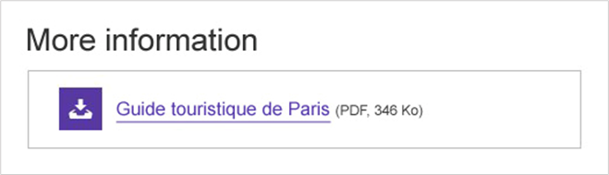

Keep accents on capital letters (for French, Spanish and any language containing accented characters)
While writing in a language containing accented characters, accents should be kept, even on capital letters.
Therefore you should write “Belle Époque” instead of “Belle Epoque”, “DÉTENTE” rather than “DETENTE”, etc.
Note
You are strongly encouraged not to write long sections of text in capital letters, because they make reading tiresome.

Make the current position visually different in each navigation system
In each navigation system, it is recommended to differentiate the appearance of the current item.

In this first example of a menu, the currently active section (“Newsletter”) is indicated
by a different text and background color, and by the arrow pointing down.
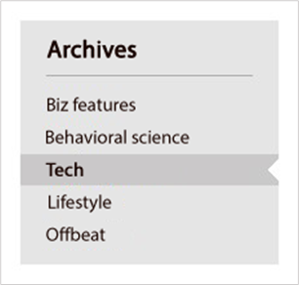
In this second example of a menu, the currently active page (“Tech”) is indicated
by a different background color, bold characters and a notch mark.
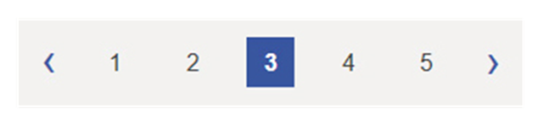
In this pagination example, the currently active page (“3”) is indicated
by a different text and background color, and bold characters.
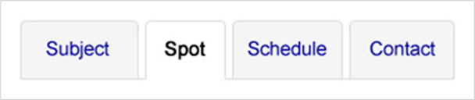
In this example of a tab system, the currently active tab (“Spot”) is indicated
by a different text and background color, and bold characters.

In this example of a navigation system within a news carousel, the currently active panel is indicated by a dot of a different color and size.
Warning
Make sure that the means for visually distinguishing current items in the navigation system are not only based on color.
Color can be completed, for instance, with:
- Bold characters.
- An icon.
- A different text size.
Note
It is also highly recommended to have a different appearance for the mouse-over of menu items.

Plan sufficiently large and spaced hotspots
It is recommended to make sure that hotspots (links and buttons, for instance) are sufficiently large (at least 0.5 x 0.5inch, i.e. 33 x 33 pt) and well-spaced from each other.

Provide a breadcrumb
It is recommended to provide a breadcrumb on each internal page of the website:
- It should show the current position of the user in the website's hierarchical structure in relation to the home page.
- It should allow the user to navigate up the hierarchy of parent pages to the home page.
- It should always be positioned in the same place on each page.
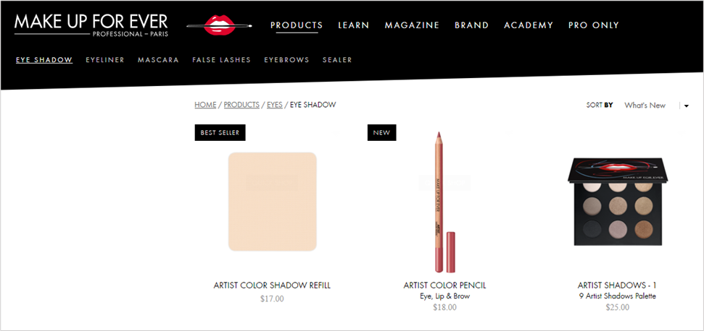
Example of a breadcrumb.
Tip
It is considered good practice to visually distinguish the last item of the breadcrumb if this is the current position.

Provide a confirmation message
Each time a form is successfully validated, it is recommended to provide a confirmation message.
This message should remind the user of the action that has been executed.
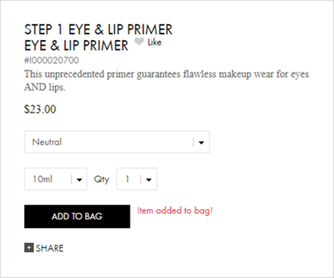
Following the addition of an item to the shopping bag, a confirmation message is clearly displayed on the screen near the « ADD TO BAG » button.
Warning
Confirmation messages must not disappear automatically.
These messages must only disappear on a user action (closing button, new page display, new form submission, etc.).
Note
In some circumstances, a confirmation message is not necessary, as the page displayed after submitting the form makes the result of the action obvious.
For example:
- A login form that sends the user to a "User profile" page.
- A "Go to next step" button that sends the user to the next step in a form with multiple steps.
- A comments form that sends the user to the posted comment.
- Etc.

Provide a heading for each data table
When data tables are used, it is recommended to associate them with a title that clearly and succinctly presents their contents.
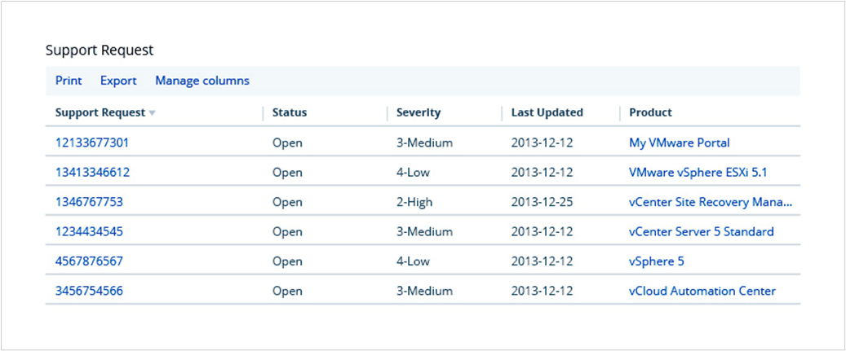
Example of a data table with a heading.

Provide an explicit link text for each link and each button
A link or button is considered as non-explicit when its text alone does not make it possible to understand its destination or function.
The following link and button texts are therefore to be avoided:
- "Read more".
- "More information".
- "Click here".
- Etc.
They should be replaced by such texts as:
- "Mr. Cameron's statement (read more)".
- "More information on the Wiltshire contract".
- "Discover our welcome offer".
- Etc.
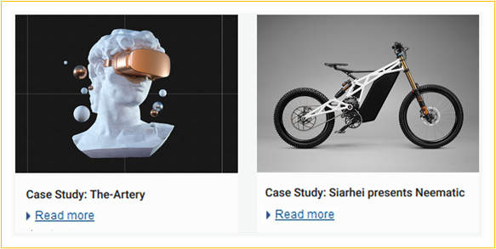
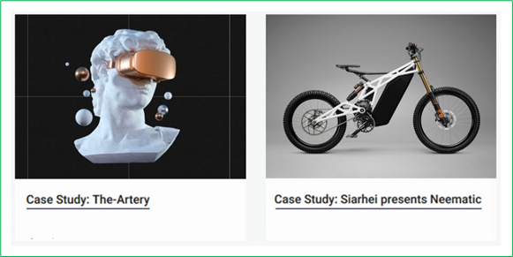
In this example, the “Read more” links have been deleted,
and the links placed directly on the heading of the case studies.
Note
If it is not practical to make some link or button texts explicit (lack of space in the mock-up, for example), there are other solutions that can be used later in the development phase.
Nevertheless, this is a compromise solution that is less effective than directly optimizing the link or the button with an explicit link text.

Provide a submit button at the end of each form
A submit button should be provided in each form, and placed at the end of the form.
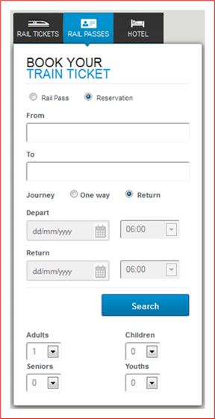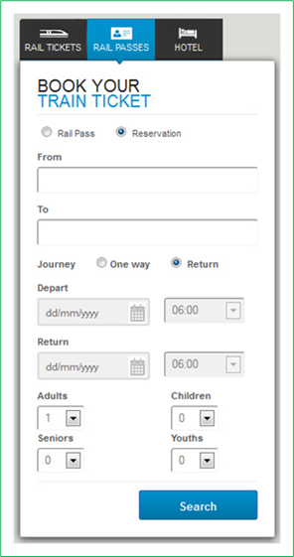
In the first example, the options “Adults”, “Seniors”, “Children” and “Youths” are placed
after the “Search” submit button. Some users may omit to enter this information.
For this reason, it is important to position the submit button
at the end of the form, as in the second example.
Note
In some circumstances, you do not need to provide a button.
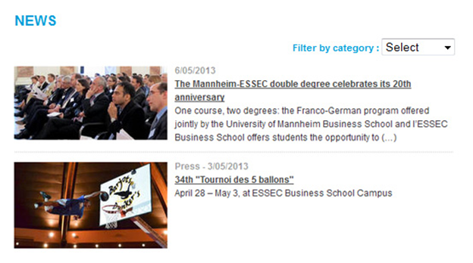
This is the case, for example, with a drop-down list for sorting a list of results dynamically, as the action is triggered dynamically when the user makes a choice.

Provide a summary prior to final submission of multi step forms
For each form containing multiple steps, a summary of all the data entered should be proposed to the user before the final submission of the form.
From this summary, it should be possible to:
- Directly edit all data.
- And/or go back to the previous steps to modify the data.
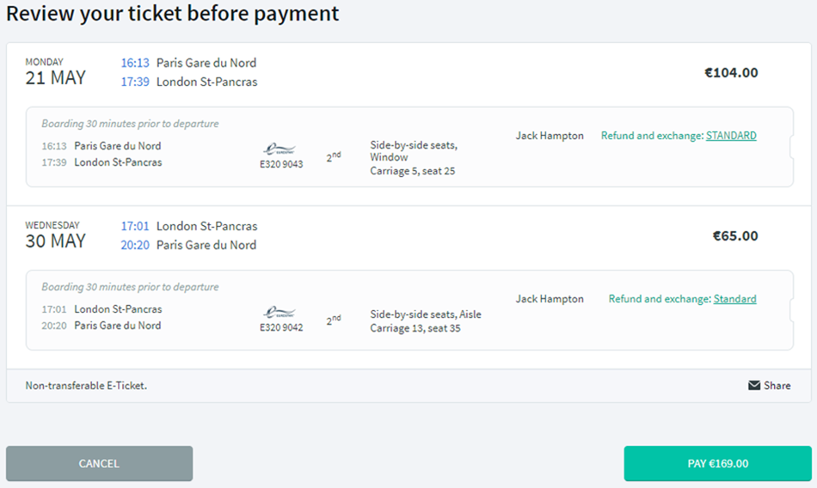
After filling out the form, a summary is provided and gives the possibility to modify the information before ordering the purchases.

Provide a way of returning to the previous steps on forms with multiple steps
For each multi-step form, it is recommended to clearly indicate the total number of steps as well as the current step.

Three steps are announced in this form. The current step is indicated by a bold effect and different text and background colors.
It is also recommended to provide a way to return to the previous steps.

In this form, 3 steps are identified and users can click on the title of step 1
to go back from a further one.

Provide skip links
It is recommended to design the "Go to Content" skip link at the top of at least one of the graphic mock-ups.
Tip
It can be hidden by default, if you prefer.
In this case, it will be made visible on keyboard access during the development phase.
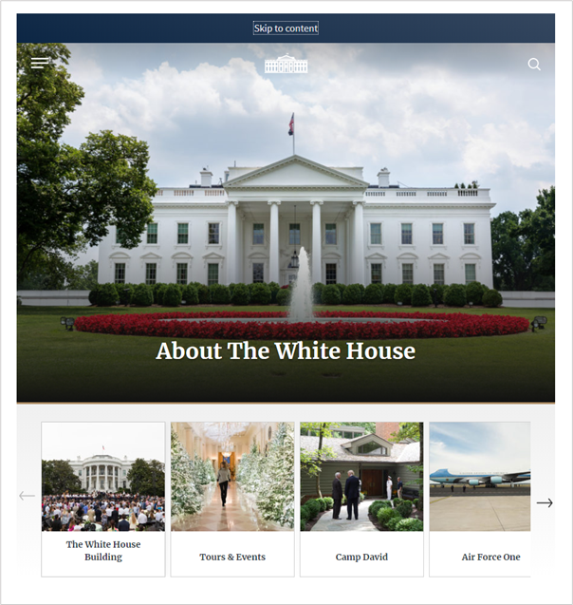
Example of a “Skip to content” skip link situated at the top of the page.
Note
Links such as “Go to menu”, and “Go to search”, can also be added besides the “Go to content” link if these items are not near the top of the page.

